Major Chord
# Source: AI Source: Provided by: [Data Path: Persons Table -> ID Column: 1, Name_En Column: Motasem Essam] -> From: [ChatGPT] on [7/25/2026]
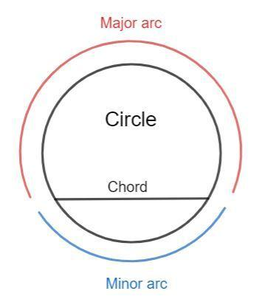
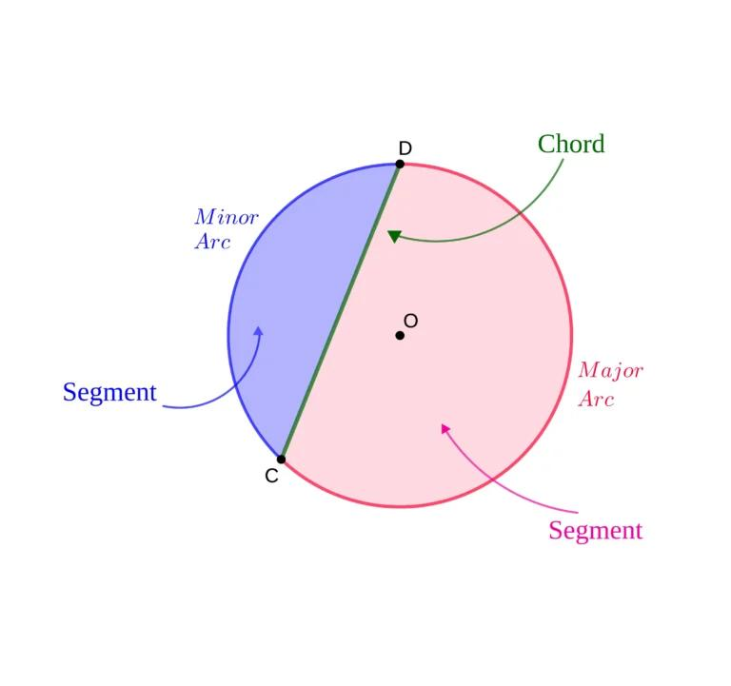
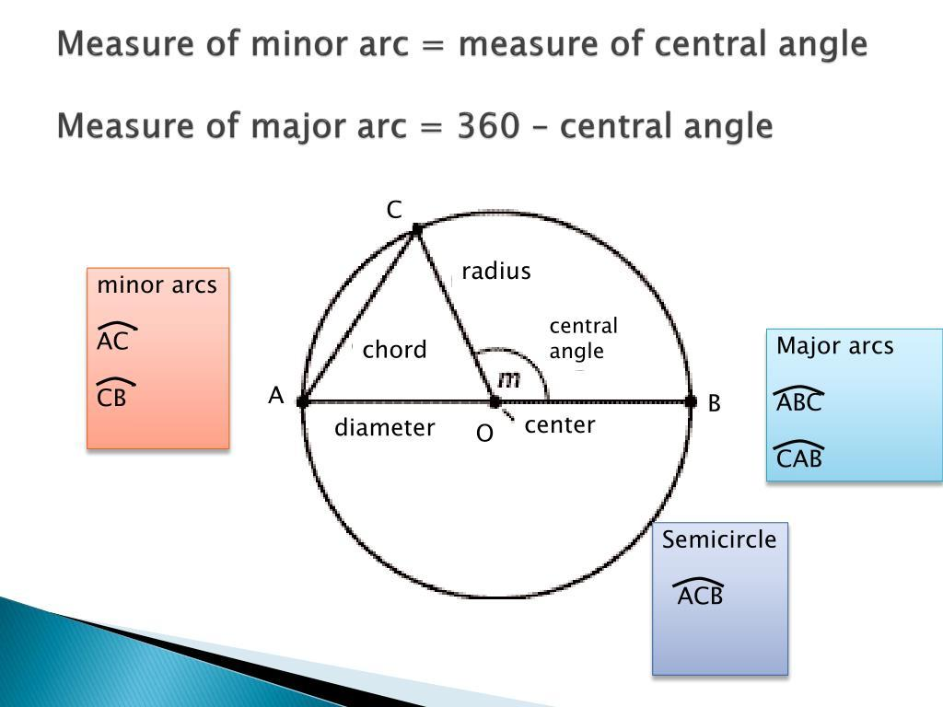
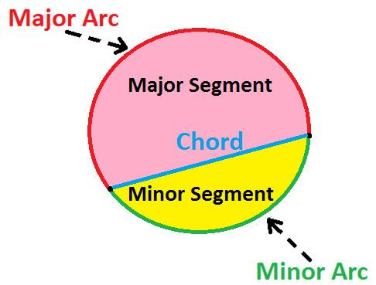
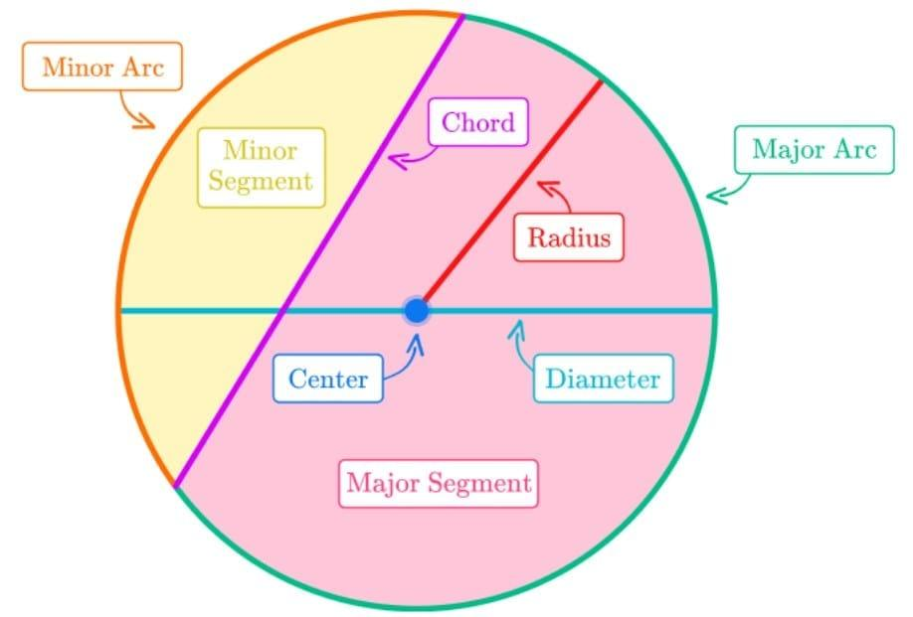

Definition
# Source: AI Source: Provided by: [Data Path: Persons Table -> ID Column: 1, Name_En Column: Motasem Essam] -> From: [ChatGPT] on [7/25/2026]
A Major Chord is a chord associated with a major arc of a circle.
The chord is the straight line segment connecting the two endpoints of the major arc.
If $A$and $B$are points on a circle and the major arc between them is $\hat{AB}$, then:
$$\overset{‾}{AB}$$
is the chord corresponding to that major arc.
Important: In formal geometry, major chord is not normally considered a standard separate type of chord. The terms minor arc and major arc describe arcs, while the straight segment connecting their endpoints is simply a chord.

Fundamental Elements
# Source: AI Source: Provided by: [Data Path: Persons Table -> ID Column: 1, Name_En Column: Motasem Essam] -> From: [ChatGPT] on [7/25/2026]
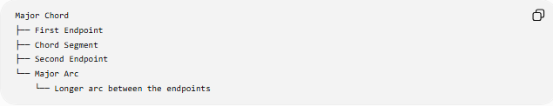
Major Chord
├── First Endpoint
├── Chord Segment
├── Second Endpoint
└── Major Arc
└── Longer arc between the endpoints
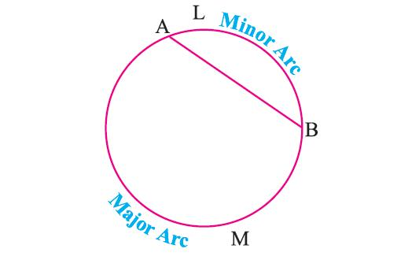

Main Properties
# Source: AI Source: Provided by: [Data Path: Persons Table -> ID Column: 1, Name_En Column: Motasem Essam] -> From: [ChatGPT] on [7/25/2026]
1. Both Endpoints Lie on the Circle
For chord $\overset{‾}{AB}$:
$$A,B∈\text{circle}$$
2. The Associated Arc Is a Major Arc
A major arc has a measure greater than ${180}^{∘}$:
$$\boxed{m\left(\hat{AB}\right)>{180}^{∘}}$$
3. The Chord Does Not Follow the Major Arc
The chord is always a straight segment.
The major arc is the long curved portion of the circumference.
4. The Same Chord Has Two Associated Arcs
For two endpoints $A$and $B$, there are two arcs:
- Minor arc $AB$
- Major arc $AB$
But there is only one chord:
$$\overset{‾}{AB}$$
This is why "major chord" is not a standard distinct chord type.
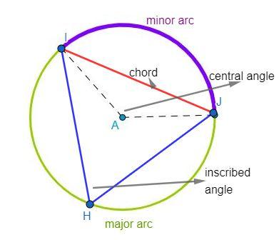

Major Chord vs Minor Chord
# Source: AI Source: Provided by: [Data Path: Persons Table -> ID Column: 1, Name_En Column: Motasem Essam] -> From: [ChatGPT] on [7/25/2026]
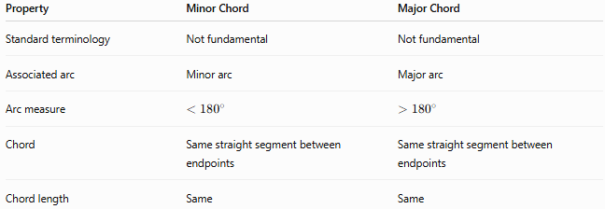
Property | Minor Chord | Major Chord
Standard terminology | Not fundamental | Not fundamental
Associated arc | Minor arc | Major arc
Arc measure | $$<{180}^{∘}$$ | $$>{180}^{∘}$$
Chord | Same straight segment between endpoints | Same straight segment between endpoints
Chord length | Same | Same
Important Observation
Suppose $A$and $B$divide a circle into a minor arc and a major arc.
The same chord $\overset{‾}{AB}$connects them.
Therefore:
$$\boxed{\text{There is no separate “major chord” corresponding to the major arc.}}$$

Chord and Arc Classification
# Source: AI Source: Provided by: [Data Path: Persons Table -> ID Column: 1, Name_En Column: Motasem Essam] -> From: [ChatGPT] on [7/25/2026]
For your knowledge base, the more mathematically accurate structure is:
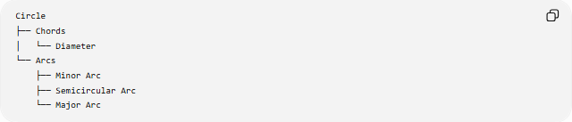
Circle
├── Chords
│ └── Diameter
└── Arcs
├── Minor Arc
├── Semicircular Arc
└── Major Arc
This is preferable to:
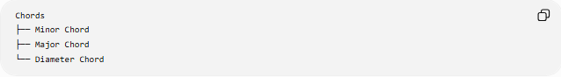
Chords
├── Minor Chord
├── Major Chord
└── Diameter Chord
because minor/major are standard classifications of arcs, while diameter is a genuine special type of chord.

Example
# Source: AI Source: Provided by: [Data Path: Persons Table -> ID Column: 1, Name_En Column: Motasem Essam] -> From: [ChatGPT] on [7/25/2026]
Consider a circle with points $A$and $B$.
If:
$$m\left(\hat{AB}\right)={240}^{∘}$$
then $\hat{AB}$is a major arc.
The segment:
$$\overset{‾}{AB}$$
is simply a chord, not a separate "major chord."
The other arc has measure:
$${360}^{∘}-{240}^{∘}={120}^{∘}$$
so it is the minor arc.
Both arcs have the same endpoints and the same chord.

Key Points
# Source: AI Source: Provided by: [Data Path: Persons Table -> ID Column: 1, Name_En Column: Motasem Essam] -> From: [ChatGPT] on [7/25/2026]
- A major arc has measure greater than ${180}^{∘}$.
- The chord connecting its endpoints is simply called a chord.
- The same chord also connects the endpoints of the corresponding minor arc.
- Therefore, “major chord” is not normally a formal chord classification.
- Diameter is a genuine special type of chord because it passes through the center.
$$\boxed{\text{Major Arc}≠\text{Major Chord}}$$

